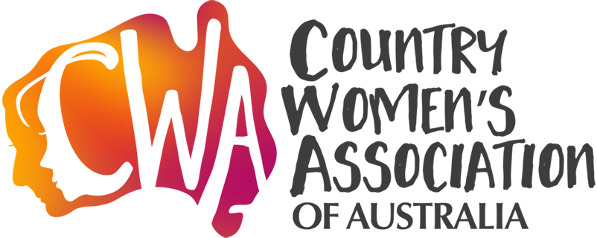

The Country Women’s Association of Australia (CWAA) is committed to high-quality health services in Rural and Remote Australia and is pleased to announce the 2019 Rural and Remote Nursing and Midwifery Professional Development Grants, in conjunction with the National Rural Health Alliance and CRANAplus.

The Grant is intended to assist rural and remote nurses and midwives to offset the costs of undertaking Continuing Professional Development. The grant is designed to enable nurses and midwives with strong links to rural and remote communities to:
- upskill;
- provide quality care; and
- meet the heath service needs of their communities.
Applications are open to Registered Nurses, Enrolled Nurses and Midwives who are commencing a program of study or course to gain new skills and broaden their knowledge. The grant will be awarded based on assessment against the selection criteria detailed in the Guidelines.
Half of the total amount will be paid at the commencement of study, which will be required to start within 12 months of being offered a grant, and the balance will be paid on successful completion of the course.
The CWAA is pleased to work with the National Rural Health Alliance and CRANAplus to offer this program for a second year in 2019.

KEY DATES:

Applications open: 1 January 2019
Applications close: 5.00 pm (AEDT), Friday, 15 February 2019 (late or incomplete applications will not be accepted).
Notification of outcome of applications will be by end-February 2019.
Application guidelines Application form
Submit completed Application forms:
Submit here

