[Insert Practice name or logo]

Quality Improvement (QI) Plan-Do-Study-Act (PDSA)

|  |  |  |  |
| --- | --- | --- | --- |
| **QI activity focus** |  | | |
| **QI activity lead/s** |  | | |
| **Start measure** |  | **End measure** |  |
| **Start date** |  | **End date** |  |

**Outline the steps you will undertake**

**What do you plan to do/achieve?**

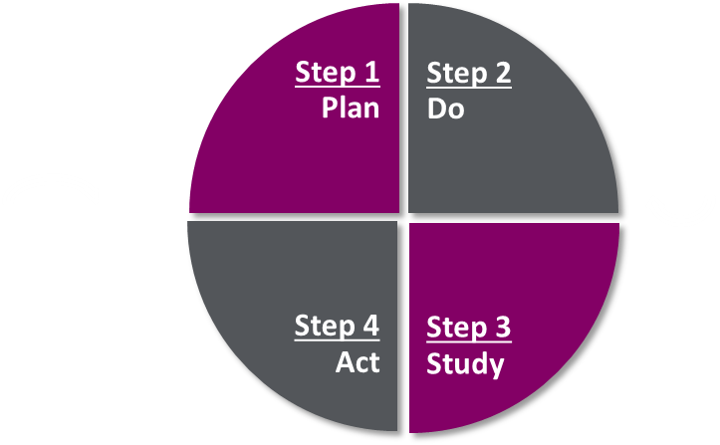

**What did you observe?**

**Will you adopt, adapt  
or abandon this change?**