Best Practice

Accessing the Medicare Overview

Note: These steps assume that your software is connected to the My Health Record system, the patient has a My Health Record and their individual healthcare identifier (IHI) has been validated in your system.

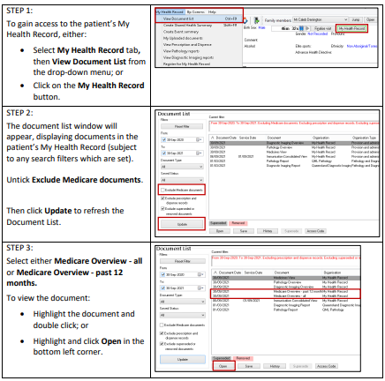

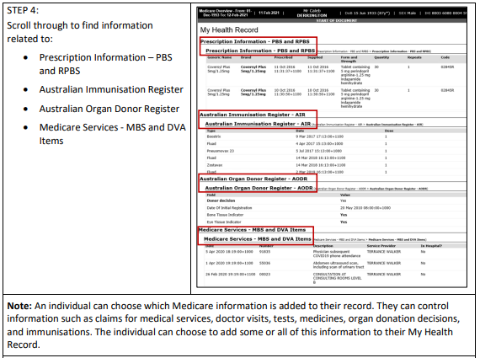

Useful Links:
- How and when to view a My Health Record
- Upcoming training opportunities, events and webinars

