Medical Director

Accessing Prescription and Dispense View

Note: These steps assume that your software is connected to the My Health Record system, the patient has a My Health Record and their individual healthcare identifier (IHI) has been validated in your system.

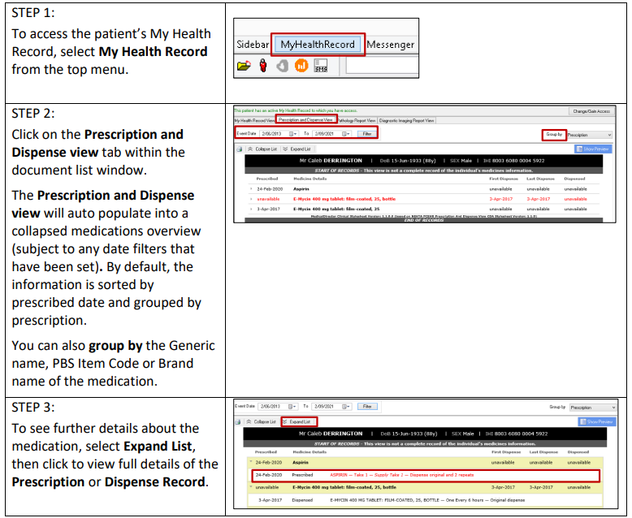

Useful Links:
- How and When to View a My Health Record:
https://www.myhealthrecord.gov.au/for-healthcare-professionals/howtos/view-my-health-record
- For upcoming training opportunities, visit Events and Webinars:
https://www.digitalhealth.gov.au/newsroom/events-and-webinars

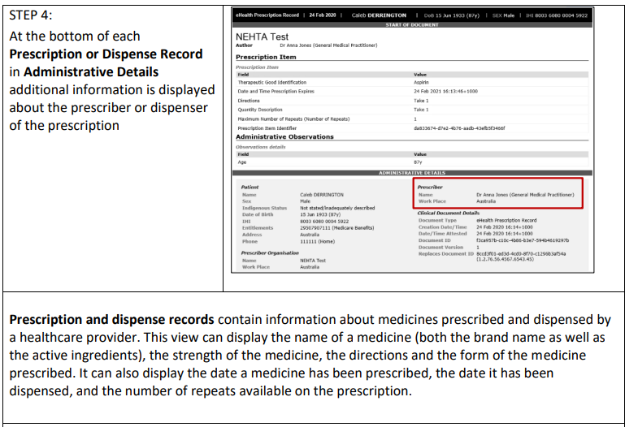

Useful Links:
- How and when to view a My Health Record
- Upcoming training opportunities, events and webinars

