Medical Director

Viewing Pathology and Diagnostic Imaging

Note: These steps assume that your software is connected to the My Health Record system, the patient has a My Health Record and their individual healthcare identifier (IHI) has been validated in your system.

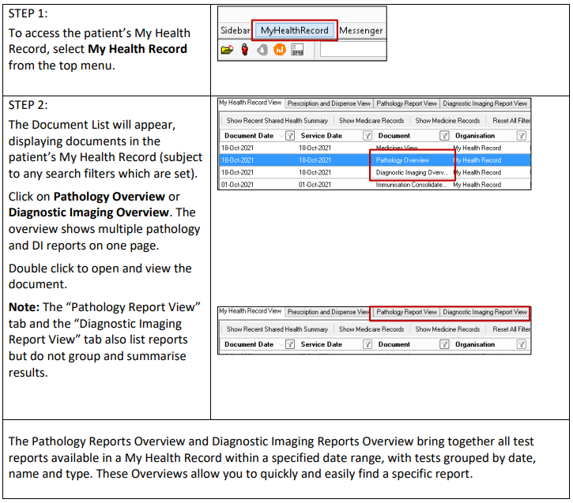

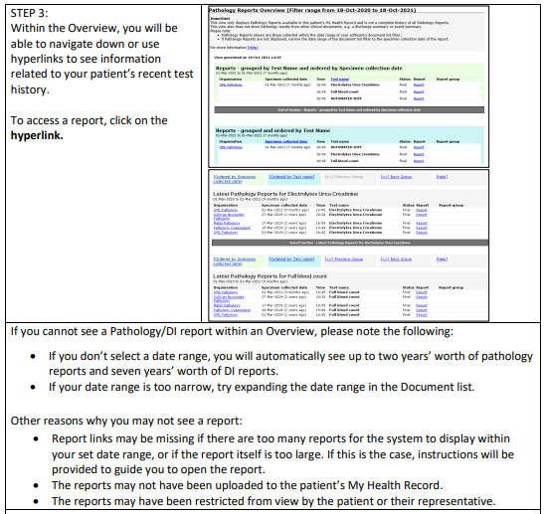

Useful Links:
- Pathology and diagnostic imaging providers uploading to My Health Record
- How and when to view a My Health Record
- Upcoming training opportunities, events and webinars

